Applied Machine & deep learning

Machine Learning (ML) is a field of Artificial Intelligence (AI) that allows computers to learn patterns from data and make predictions or decisions without being explicitly programmed.
Instead of writing rules, we give the machine data, and it learns patterns automatically.
Types of Machine Learning
1️⃣ Supervised Learning (Most common)
The model learns using labeled data (with correct answers).
Used for:
- Predicting numbers → Regression
- Predicting categories → Classification
Examples:
- Predicting house prices
- Predicting whether a customer will leave

2️⃣ Unsupervised Learning
The model finds patterns without labels (unlabeled data)
Used for:
- Grouping → Clustering
- Finding hidden patterns
- Anomaly detection
Examples:
- Customer segmentation

Traditional SDLC (Software Development Life Cycle) & Agile ML Workflow
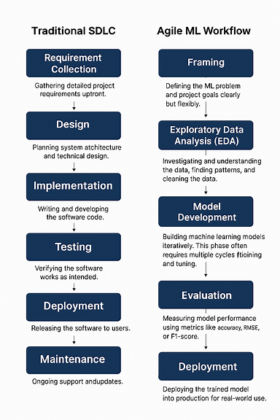
- Hyperparameters vs Parameters
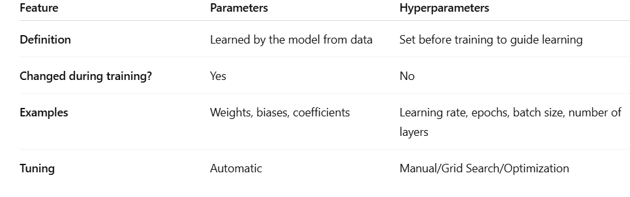
Hyperparameter Tuning Methods
- Grid Search: Tests all hyperparameter combinations; often combined with cross-validation. Exhaustive but computationally heavy.
- Random Search: Samples random combinations; faster, may miss the best set. Can use cross-validation for reliability.
- Cross-Validation Selection: Uses k-fold cross-validation to evaluate hyperparameters, improving generalization but adds computation.

- Machine Learning Workflow

1. Problem Definition
Clearly define what you are trying to predict or classify, the goal of the project, and how success will be measured.

2. Data Collection
Gather the data needed for the problem from sources like databases, APIs, sensors, web scraping, or datasets.

3. Data Cleaning
Prepare the data by fixing errors, removing duplicates, handling missing values, and dealing with outliers.

4. Exploratory Data Analysis (EDA)
Analyze the data using visualizations and statistics to understand patterns, distributions, relationships, and anomalies.

5. Feature Engineering
Transform raw data into meaningful inputs for the model (encoding, scaling, generating new features, text/vector extraction).

6. Feature Selection
Choose the most important features to reduce noise, improve training speed, and prevent overfitting.

7. Model Selection
Choose the best algorithm (e.g., Random Forest, SVM, Neural Network) based on the data type and problem.

8. Model Training
Fit the selected model to the training data so it can learn underlying patterns.

9. Model Evaluation
Evaluate model performance on validation/test data using metrics like accuracy, precision, recall, F1-score, RMSE, etc.

10. Hyperparameter Tuning
Optimize the model's settings using techniques like grid search, random search, or Bayesian optimization.

11. Deployment
Deploy the model to production so it can be used in real applications (APIs, mobile apps, cloud services).

12. Monitoring & Maintenance
Continuously track model performance, detect model drift, retrain with new data, and update features or parameters.

- GENERALIZATION IN MACHINE LEARNING
Generalization is an ML model’s ability to perform well on new, unseen data after being trained on a specific dataset.
A model that generalizes well has truly learned patterns, not memorized examples.

- What is Linear Search?
Linear Search is a simple search algorithm that checks each element in a list one by one until it finds the target value or reaches the end of the list.
It is also called sequential search.
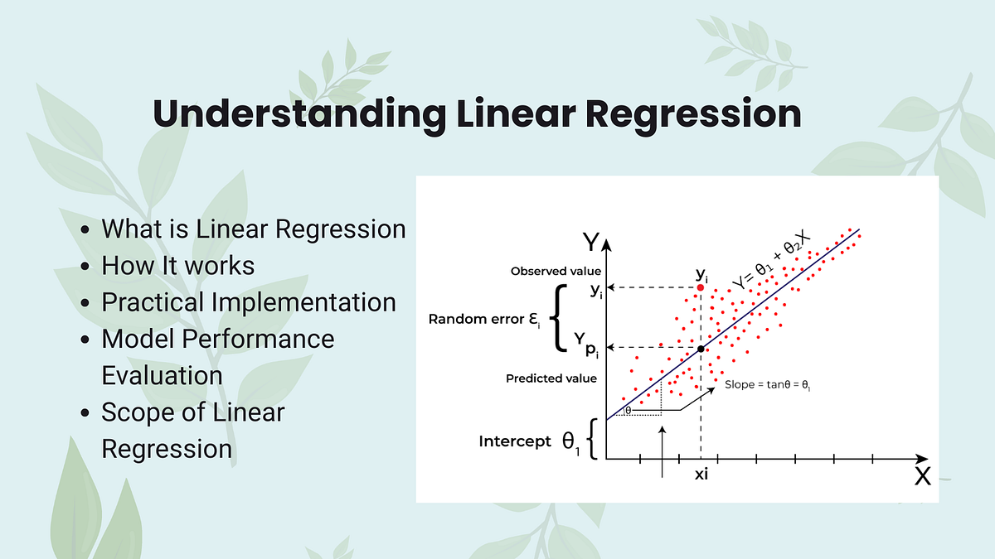

Importance of Linear Search :
- Simple and easy to implement.
- Works on unsorted data.
- No extra memory required.
- Efficient for small datasets.
- Useful for learning basic algorithm concepts.

